Ideation Phase

Define the Problem Statements

|  |  |
| --- | --- |
| Date | 19 September 2022 |
| Team ID | PNT2022TMID52128 |
| Project Name | A Gesture-based Tool for Sterile Browsing of Radiology Images |
| Maximum Marks | 2 Marks |

**Customer Problem Statement Template:**

Create a problem statement to understand your customer's point of view. The Customer Problem Statement template helps you focus on what matters to create experiences people will love.

A well-articulated customer problem statement allows you and your team to find the ideal solution for the challenges your customers face. Throughout the process, you’ll also be able to empathize with your customers, which helps you better understand how they perceive your product or service.

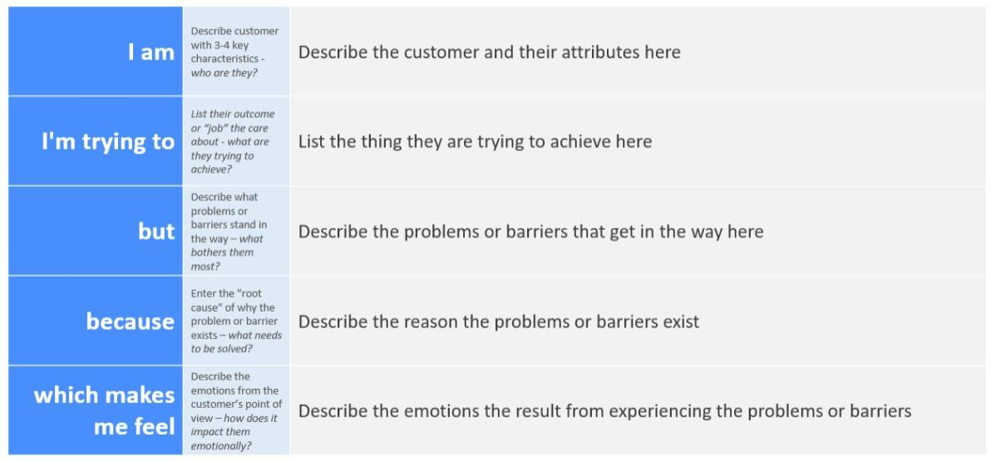

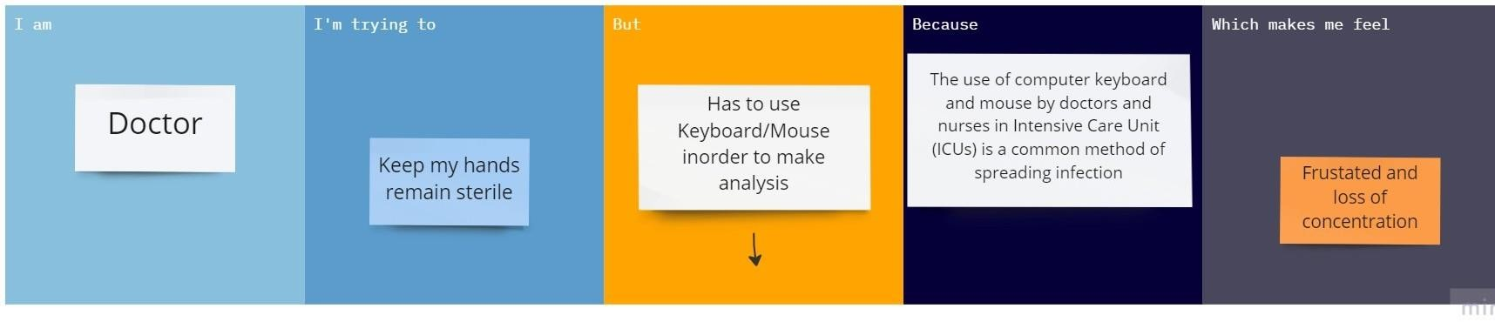



|  |  |  |  |  |  |
| --- | --- | --- | --- | --- | --- |
| **Problem Statement**  **(PS)** | **Iam (Customer)** | **I’m trying to** | **But** | **Because** | **Which makes me feel** |
| PS-1 | Doctor | Keep my hands remain sterile | Has to use Keyboard/Mouse inorder to make analysis | The use of computer keyboard and mouse by doctors and nurses in Intensive Care Unit (ICUs) is a common method of  spreading infection | Frustated and loss of concentration |
| PS-2 | Doctor/Surgeon | Manipulate radiology images using sterile methods | It disturbs the patients | Of the noise produced during noise recognition system | Annonying and frustrating |